**E-commerce Platform Search Function**

Big O Notation:

Big O Notation is used to determine how fast or slow an algorithm will work based on the size of the input. It shows how much time is used for the algorithm to execute for a particular input size. Example: For a particular question, it can be solved using multiple algorithm, Big O notation is used to compare which algorithm is better/faster for large inputs.

Best, Average, and Worst Case:

Considering example of Linear Search,

* Best Case: The fastest case.

Example: In linear search, if item is at first position so the algorithm stops at first element, so time complexity is O(1).

* Average Case: The case after running many times.

Example: In linear search, when an item is somewhere in middle so time complexity is O(n).

* Worst Case: The slowest case.

Example: In linear search , when the item is at last or if it is not present, the algorithm still checks all the elements so time complexity is O(n).

OUTPUT:

Sample Output 1:

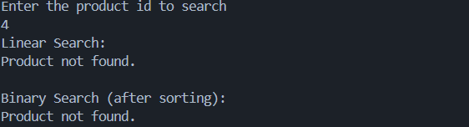

Sample Output 2:

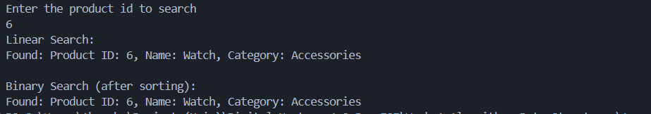

Time complexity for Linear Search is O(n) as it checks all the elements one by one and the time complexity for Binary Search is O(log n) as it divides the array in half and then checks it so it is comparatively faster.

In this Ecommerce platform, Binary Search is better because the number of products will continuously increase over time, and Linear Search would not be efficient for handling such a large number. Binary Search offers much faster performance on sorted data.